Created and started minikube in my local system version details are provide below
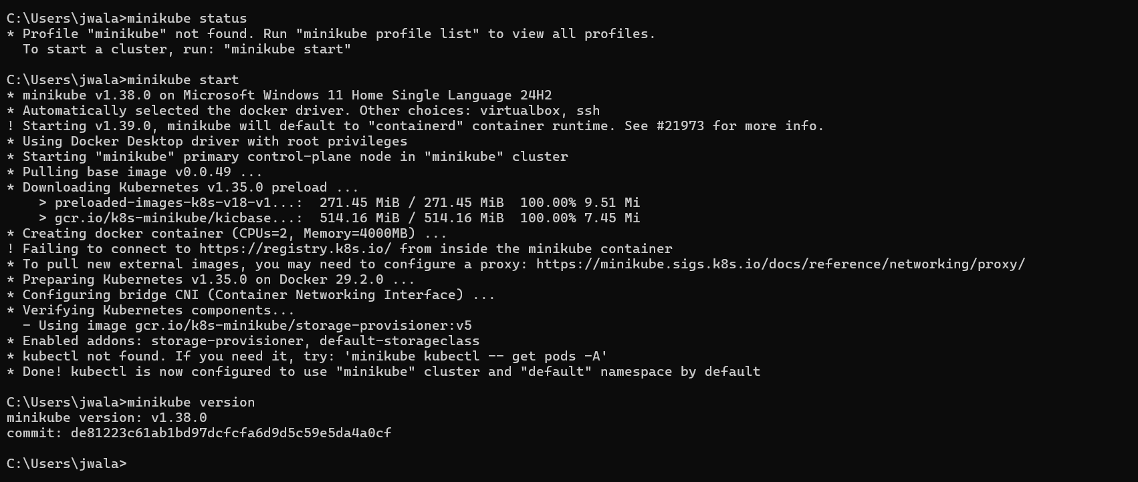

Namespace
There will be 4 default namespace available which is shown below
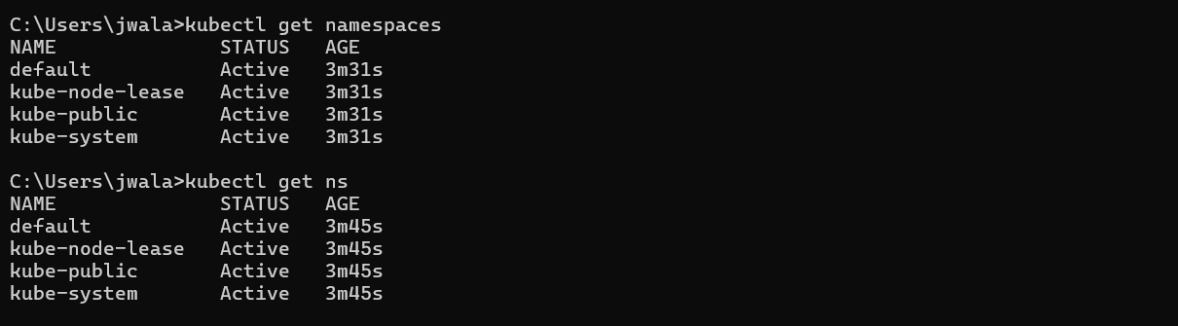
Created a dev and testing namespace
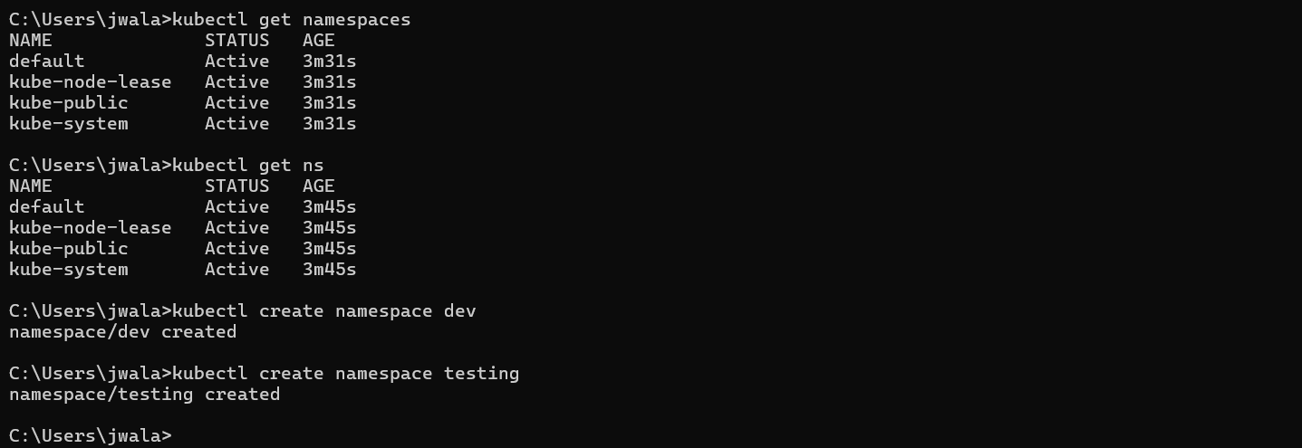

Changing the default namespace to dev
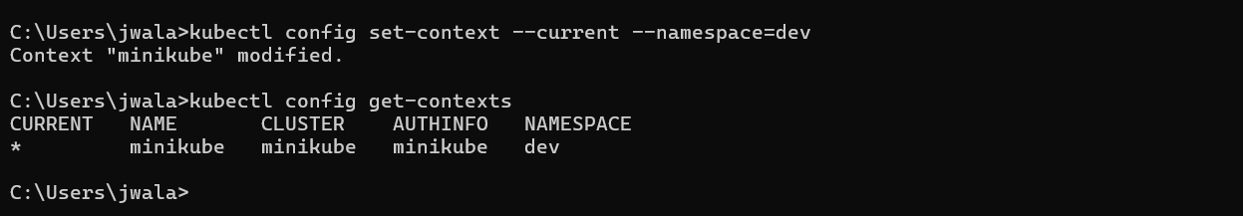
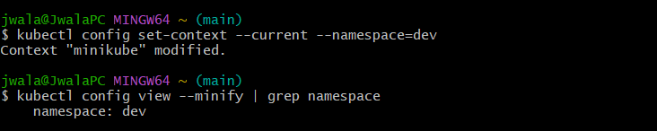

Creating a pod inside a particular namespace
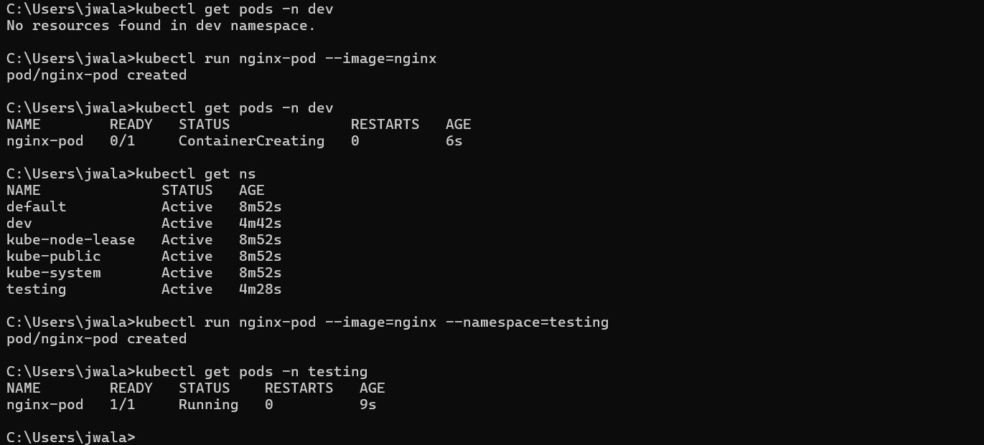

Getting details of namespace
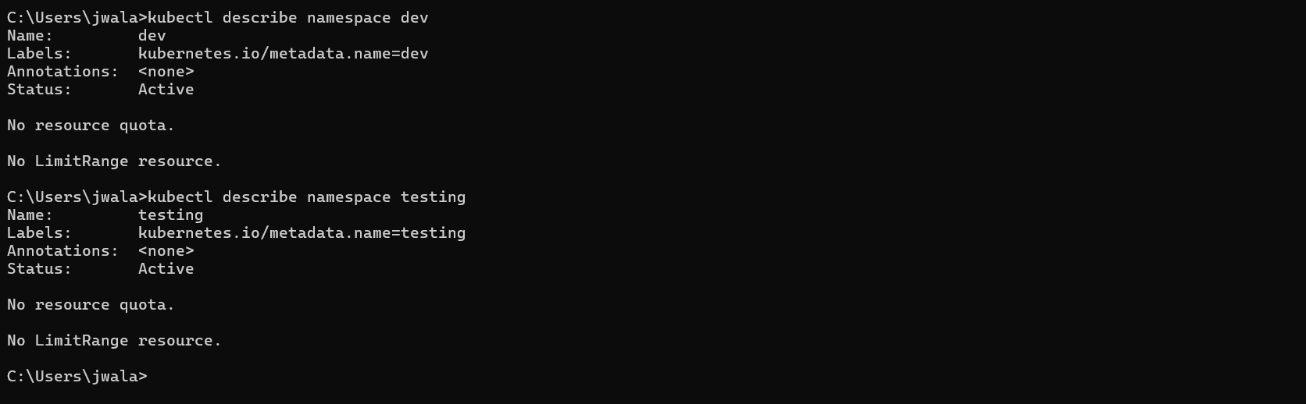
Deleating a namespace
